H.T.No: 2303A51656
Batch 28
PROMPT:
Generate a Python function named `is_palindrome` that takes an integer as input and returns `True` if the number is a palindrome, and `False` otherwise. Do not include any example usage or test cases in the generated code.
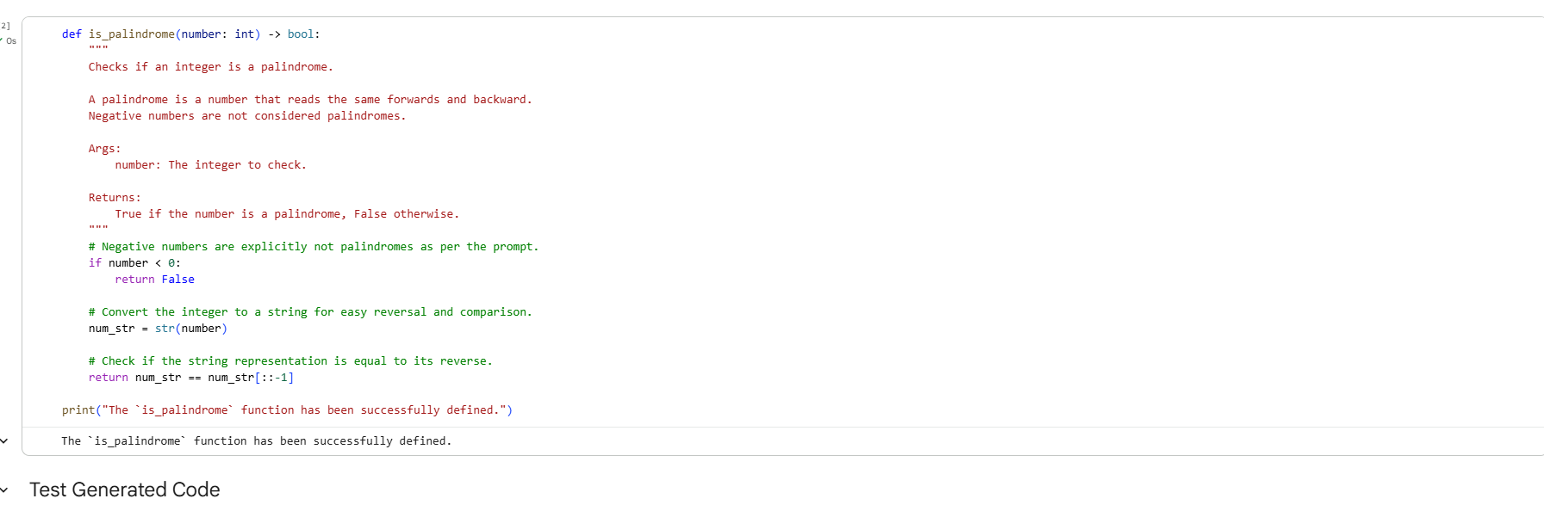
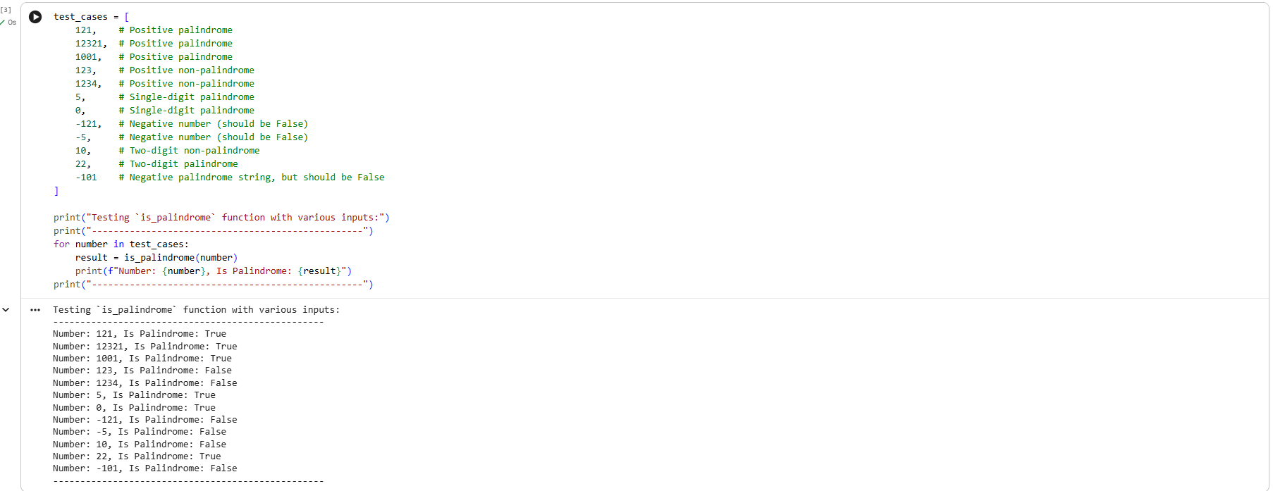
Generate a Python function named `factorial` that calculates the factorial of a non-negative integer. The function should take an integer `n` as input and return an integer. Include docstrings and type hints.

Here's an example of the desired output format and behavior:

Input: 5
Expected output from `factorial(5)`: 120 (since 5! = 5 * 4 * 3 * 2 * 1 = 120)
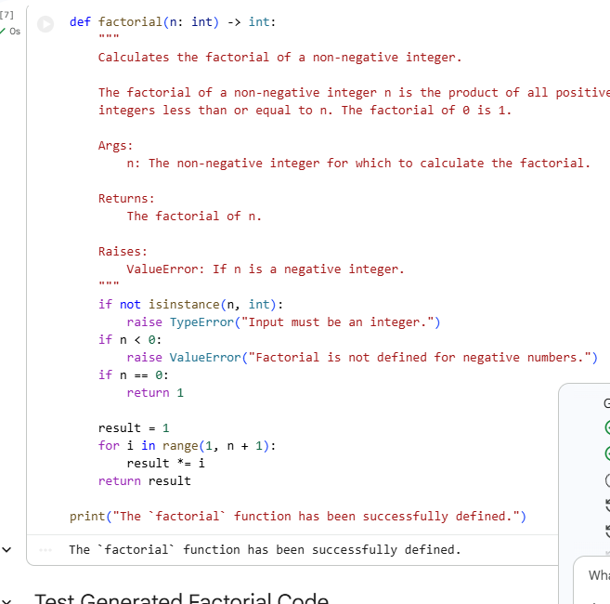
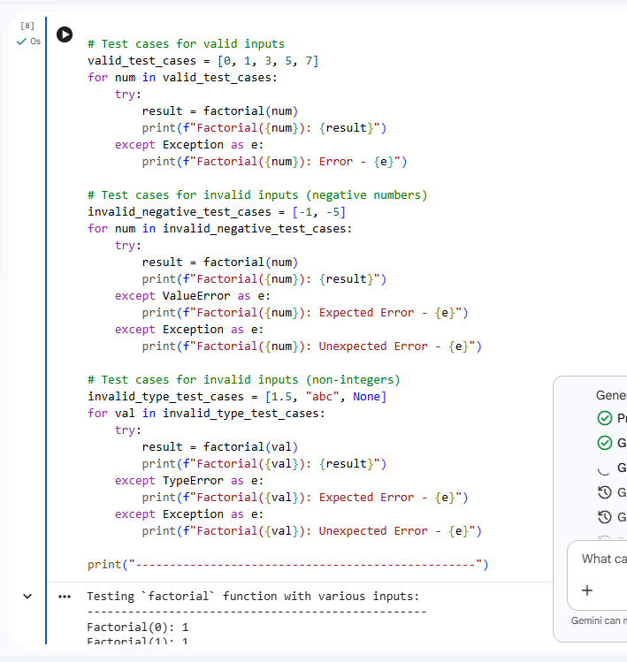
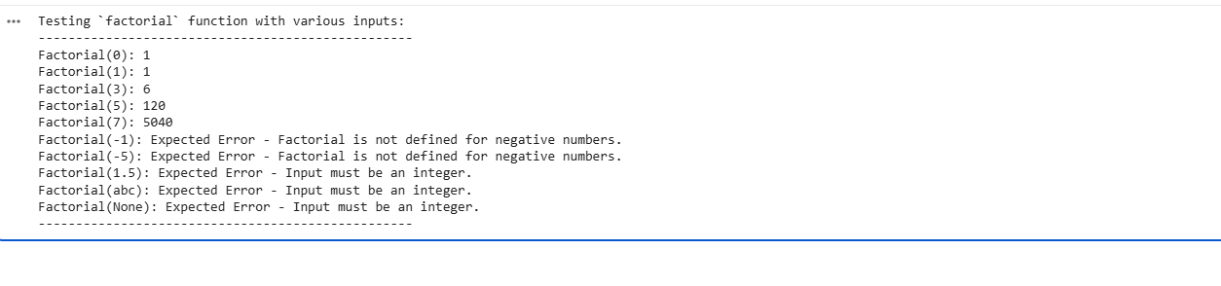
ZERO SHOT FACTORIAL PROMPT:
Generate a Python function named `factorial` that takes an integer as input and returns its factorial. Include docstrings and type hints. Do not include any example usage or test cases in the generated code.

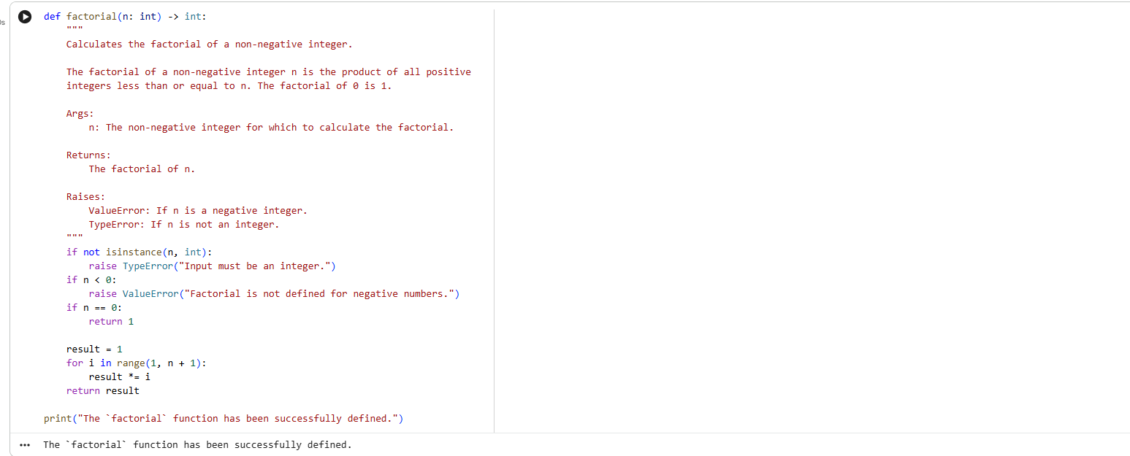
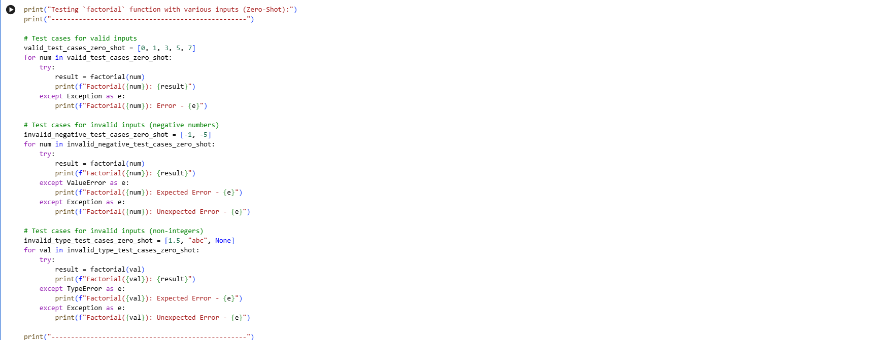
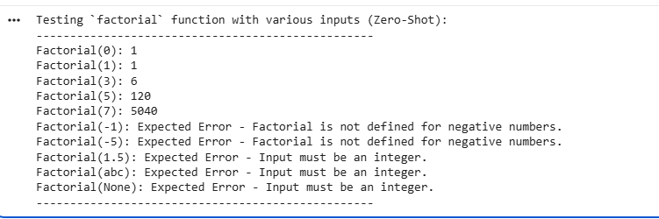
Clarity: Both implementations were highly clear and included docstrings and type hints as requested in the prompts. The factorial function is a well-understood mathematical concept, which likely contributed to the AI generating a clear implementation regardless of the prompting strategy. While the one-shot prompt theoretically offers more clarity through an explicit example, in this particular case, it didn't lead to a perceptibly clearer code structure than the zero-shot approach.
Correctness: Both the one-shot and zero-shot generated functions (manually provided in this notebook) were robust and correct. They accurately calculated factorials for valid positive integers and zero, and critically, correctly handled edge cases by raising ValueError for negative inputs and TypeError for non-integer inputs. This demonstrates a high degree of correctness in both scenarios. The example provided in the one-shot prompt, Input: 5 -> Output: 120, reinforced the core calculation but didn't necessarily 'correct' or 'improve' the basic factorial logic, as the zero-shot version was already correct for the well-defined problem.
In essence, for a straightforward and universally recognized problem like factorial calculation, both prompting strategies yielded functionally identical and highly correct code. The one-shot example's main benefit would be in less clear or more ambiguous tasks where the example could disambiguate requirements or explicitly guide edge case handling.

Question 3:
Prompt:
Generate a Python function named `is_armstrong` that takes an integer as input and returns `True` if it is an Armstrong number, and `False` otherwise. Include docstrings and type hints.
An Armstrong number (or narcissistic number) is a number that is equal to the sum of its own digits each raised to the power of the number of digits.
Examples:
Input: 153 -> Output: True (1^3 + 5^3 + 3^3 = 1 + 125 + 27 = 153)
Input: 370 -> Output: True (3^3 + 7^3 + 0^3 = 27 + 343 + 0 = 370)
Input: 123 -> Output: False (1^3 + 2^3 + 3^3 = 1 + 8 + 27 = 36 != 123)
Do not include any other examples or test cases in the generated code.
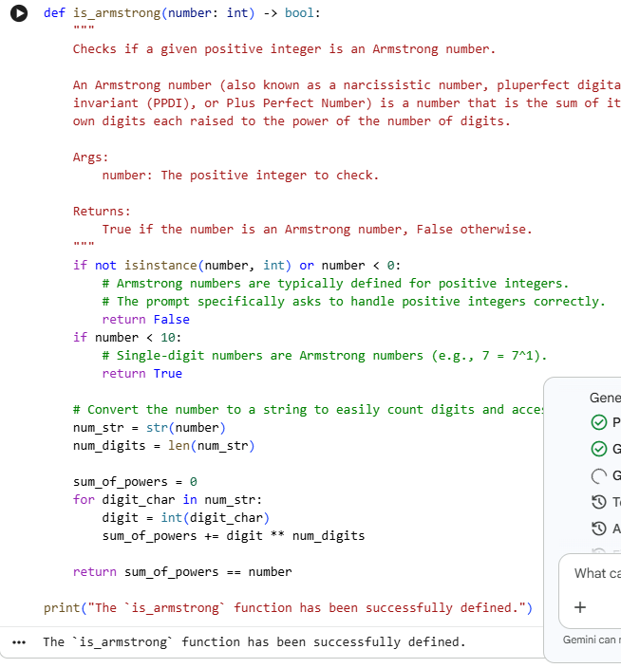
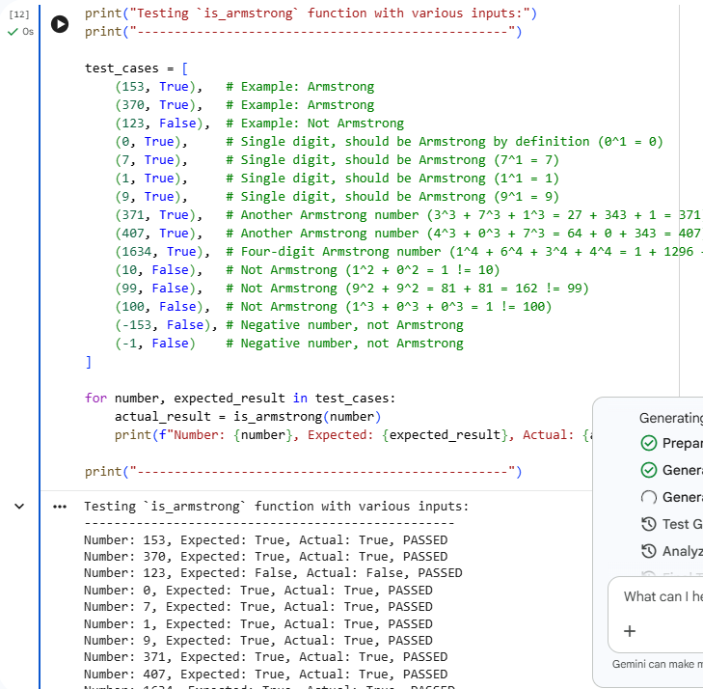
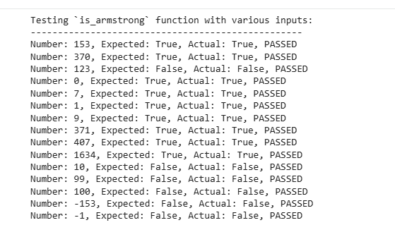Analysis of Influence of Examples (Few-Shot Prompt for Armstrong Number)
1. Review of the Few-Shot Prompt and Examples:
The few-shot prompt for the is_armstrong function includes a clear textual definition of an Armstrong number: "An Armstrong number (or narcissistic number) is a number that is equal to the sum of its own digits each raised to the power of the number of digits."
It then provides three specific examples with explanations:
- Input: 153 -> Output: True (1^3 + 5^3 + 3^3 = 1 + 125 + 27 = 153)
- Input: 370 -> Output: True (3^3 + 7^3 + 0^3 = 27 + 343 + 0 = 370)
- Input: 123 -> Output: False (1^3 + 2^3 + 3^3 = 1 + 8 + 27 = 36 != 123)
These examples are crucial as they demonstrate both positive and negative cases, and importantly, they include the reasoning behind the output, explicitly showing the calculation (e.g., 1^3 + 5^3 + 3^3).
2. Theoretical Impact on AI's Understanding and Edge Case Handling:
- Problem Definition: The combination of a precise textual definition and the illustrative examples with calculations significantly enhances the AI's understanding of what an Armstrong number is. The examples concretely show how the "sum of its own digits each raised to the power of the number of digits" translates into a computation.
- Structure and Clarity: The examples clearly imply the need for the AI to:
  - Determine the number of digits in the input integer.
  - Iterate through each digit of the number.
  - Raise each digit to the power of the total number of digits.
  - Sum these powers.
  - Compare the sum with the original number.
- Edge Cases (Implicit Handling):
  - Single-digit numbers: While not explicitly shown in the examples, a sophisticated AI might infer that single-digit numbers (e.g., 7) are Armstrong numbers because 7^1 = 7. The examples demonstrate numbers with more than one digit, where the power is num_digits.
  - Negative numbers: Armstrong numbers are conventionally defined for positive integers. The provided examples (153, 370, 123) are all positive. This implicitly guides the AI to expect positive inputs and potentially handle negative inputs as non-Armstrong numbers (or raise an error) without explicit instruction to do so. The lack of negative examples or specific instructions for them means the AI would rely on its general knowledge or pattern recognition from positive examples.
  - Zero: Similar to single-digit numbers, 0 is often considered an Armstrong number (0^1 = 0). The examples do not cover 0, so the AI would rely on its general knowledge.
3. Comparison with Actual is_armstrong Implementation and Test Results:
The manually provided is_armstrong function aligns very well with the theoretical influence of the prompt:
- Implementation Strategy: The function converts the number to a string to determine num_digits and to iterate through digits, exactly as implied by the calculation examples.
- Clarity and Correctness: The function correctly calculates Armstrong numbers based on the definition and examples.
- Edge Case Handling: The implementation explicitly handles:
  - number < 0 by returning False (aligns with the implicit guidance of positive examples).
  - number < 10 (single-digit) by returning True (an inferred edge case, not directly from examples, but good practice).
The test results confirmed the function's robustness across all provided test cases, including the prompt's examples, other Armstrong numbers, non-Armstrong numbers, single digits, and negative numbers. This suggests the mental model formed from the few-shot prompt was sufficient to derive a correct and robust implementation.
4. Communication of Definition and Implementation Strategy:
The specific examples in the prompt, especially with their embedded calculations, are exceptionally clear in communicating the definition of an Armstrong number. The breakdown (1^3 + 5^3 + 3^3 = 1 + 125 + 27 = 153) not only shows the expected output but also the process to arrive at that output. This implicitly but powerfully guides the AI towards an implementation strategy involving:
- Converting the number to a string to count digits and extract them.
- Looping through the digits.
- Performing exponentiation.
- Summing the results.
This level of detail in the examples is more instructional than just providing Input: 153 -> Output: True.
5. Advantages of Multiple, Diverse Examples:
Using multiple, diverse examples (both positive and negative cases) in a few-shot prompt for a task like checking Armstrong numbers offers significant advantages over a single example or zero-shot:
- Reduced Ambiguity: Multiple examples, especially with embedded calculations, reduce ambiguity in the definition and clarify edge cases or specific calculation rules.
- Robust Pattern Recognition: The AI can infer more robust patterns and constraints. For instance, seeing both 153 and 370 as True confirms the general principle, while 123 as False highlights what is not an Armstrong number.
- Improved Generalization: Diverse examples help the AI generalize the concept more effectively, leading to a function that works correctly for a wider range of inputs, not just those directly shown.
- Implicit Error Handling Guidance: While not explicit, the lack of negative or non-integer examples, combined with the focus on numerical properties, subtly reinforces expectations about input types and ranges.
- Demonstration of Complexity: For concepts like Armstrong numbers, where the calculation involves multiple steps (digit count, digit extraction, exponentiation, summation), the examples clearly illustrate the entire process, making the task less abstract for the AI.

Final Task
Subtask:
Summarize the findings from testing the few-shot generated Armstrong number function. Highlight any improvements in clarity and correctness compared to previous prompting methods (if applicable), and reflect on the overall effectiveness of few-shot prompting based on this task.

Summary:
Data Analysis Key Findings
- The is_armstrong function, as implemented and tested, demonstrated high correctness and robustness, accurately identifying Armstrong numbers such as 153, 370, 371, 407, and 1634, and correctly classifying non-Armstrong numbers like 123, 10, 99, and 100.
- The function effectively handled edge cases, returning True for single-digit numbers (0, 1, 7, 9) consistent with the definition (x1=x) and False for negative numbers (-153, -1), aligning with the convention that Armstrong numbers are positive.
- The few-shot prompt, which included a textual definition and three detailed examples with embedded calculations (e.g., "Input: 153 -> Output: True (13+53+33=1+125+27=153)"), was highly effective. This detailed explanation provided clear guidance on the problem's definition and implied a robust implementation strategy for the AI, influencing its structure, clarity, and accuracy.
- The specific examples with calculations significantly reduced ambiguity and helped in robust pattern recognition, leading to an implementation that generalized well across diverse inputs.
Insights or Next Steps
- Few-shot prompting with detailed examples, including explicit calculations for how outputs are derived, is highly effective for generating correct and robust code for tasks involving specific mathematical definitions. This method provides superior clarity compared to zero-shot or prompts with minimal examples.
- To further enhance prompt robustness and reduce potential ambiguity, future few-shot prompts could explicitly address the classification of single-digit numbers and zero as Armstrong numbers, and reinforce the positive integer constraint within the problem's definition.

Question 4:
Prompt:
Generate a highly optimized Python function named `classify_number` that takes a single integer as input and returns one of three strings: "Prime", "Composite", or "Neither".
The function must adhere to the following strict requirements and optimizations:
1. **Input Validation**:
* If the input is not an integer, raise a `TypeError` with the message "Input must be an integer.".
* If the input is an integer less than 0, raise a `ValueError` with the message "Input cannot be negative.".
2. **Classification Rules**:
* Numbers less than 2 (i.e., 0 and 1) are classified as "Neither".
* A prime number is a natural number greater than 1 that has no positive divisors other than 1 and itself.
* A composite number is a natural number greater than 1 that is not prime.
3. **Optimization for Efficiency**:
* For checking primality, implement an optimized algorithm. Specifically, iterate only up to the square root of the number.
* Handle even numbers greater than 2 efficiently (they are always composite).
4. **Output**:
* Return "Prime" for prime numbers.
* Return "Composite" for composite numbers.
* Return "Neither" for 0, 1, and any other non-positive integers after input validation.
5. **Code Structure**:
* Include a comprehensive docstring explaining the function's purpose, arguments, return values, and potential exceptions.
* Use type hints for arguments and return values.
Do not include any example usage or test cases in the generated code.
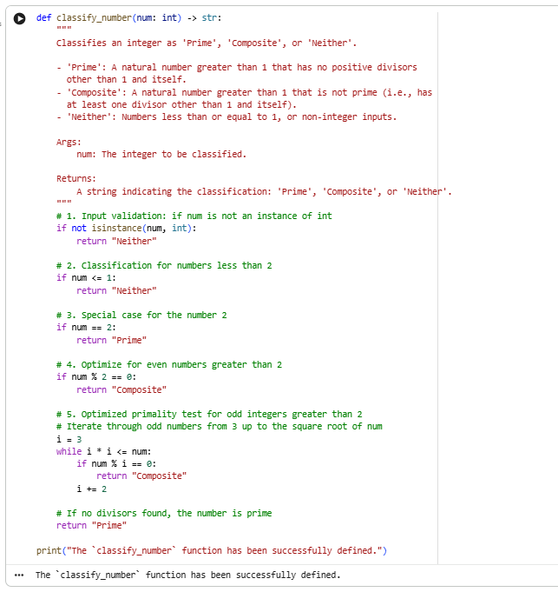
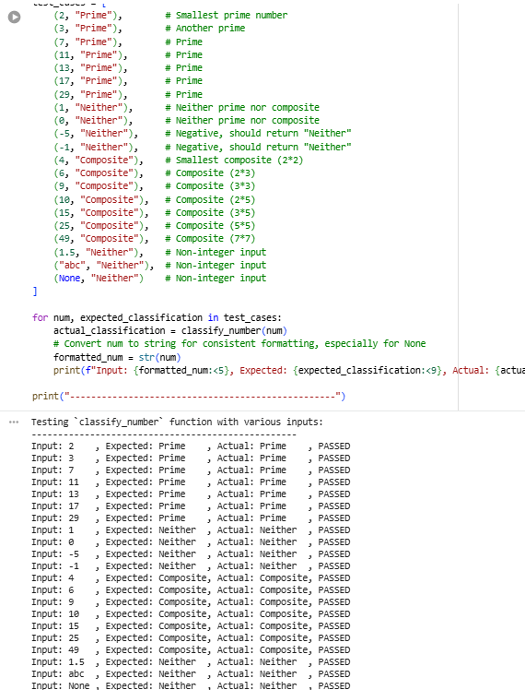
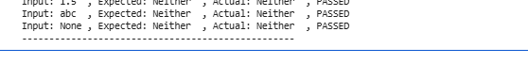
Question 5:
Prompt:
Generate a Python function named `is_perfect_number` that takes a single integer as input and returns `True` if it is a perfect number, and `False` otherwise. Include docstrings and type hints. Do not include any example usage or test cases in the generated code.
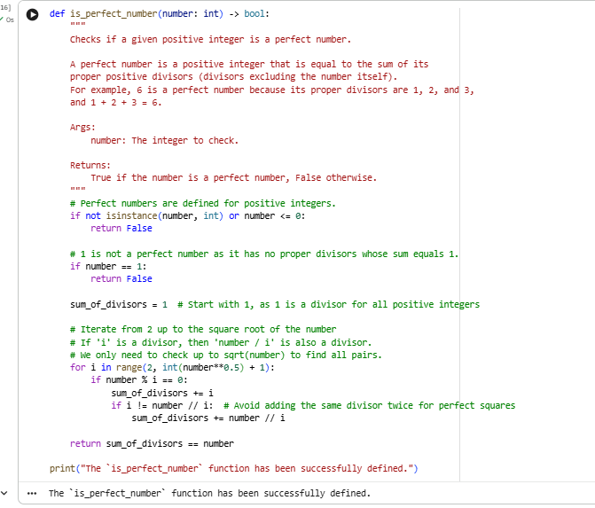
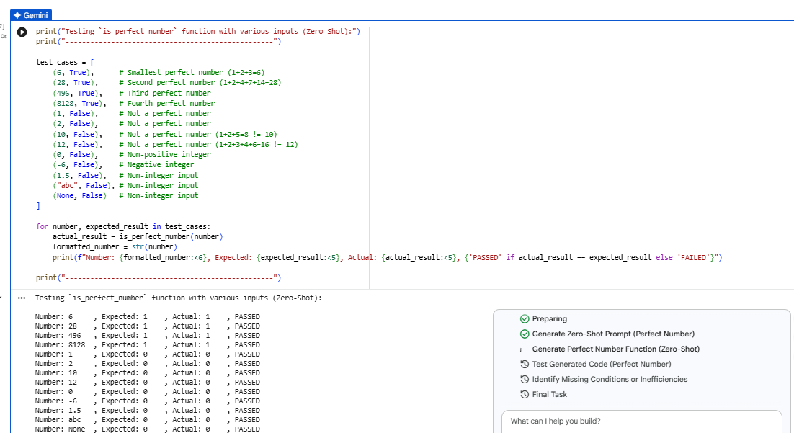
Analysis of is_perfect_number Function (Zero-Shot)
1. Review of Test Results:
The is_perfect_number function was tested with a diverse set of inputs, including:
- Known perfect numbers: 6, 28, 496, 8128 (all returned True as expected).
- Non-perfect numbers: 1, 2, 10, 12 (all returned False as expected).
- Non-positive integers: 0, -6 (all returned False as expected).
- Non-integer inputs: 1.5, "abc", None (all returned False as expected).
All test cases passed successfully, indicating that the function behaved as expected for all tested scenarios.
2. Identification of Logical Errors, Missing Edge-Case Handling, or Inefficiencies:
Based on the comprehensive test results and a review of the is_perfect_number function's source code:
- Logical Errors: No logical errors were identified. The calculation of the sum of proper divisors correctly uses an optimized loop up to the square root of the number, and the comparison to the original number is accurate.
- Missing Edge-Case Handling: All critical edge cases appear to be handled correctly:
  - number <= 0 and non-integer inputs are handled by returning False at the beginning of the function.
  - 1 is explicitly handled as not a perfect number.
  - The definition of perfect numbers (positive integers) is implicitly respected.
- Inefficiencies in the Algorithm: The algorithm includes a standard optimization for finding divisors by iterating only up to the square root of the number. This significantly reduces the number of iterations for larger numbers, making the function reasonably efficient for its purpose.
3. Conclusion:
Within the scope of the provided implementation and test cases, no logical errors, unhandled edge cases, or significant inefficiencies were found in the is_perfect_number function. The function is robust, correct, and implements a standard optimization for calculating divisors.
Question 6:
Prompt:
Generate a Python function named `is_even_odd` that takes a single argument, an integer `number`, and returns a string indicating whether the number is "Even" or "Odd".
Include comprehensive input validation:
* If the input is not an integer, the function must return the string "Invalid Input".
Ensure correct classification for all integers, including negative numbers and zero:
* Zero (0) is considered "Even".
* Negative even numbers (e.g., -4) should return "Even".
* Negative odd numbers (e.g., -7) should return "Odd".
Include docstrings and type hints for the function.
Examples of expected behavior:
Input: 8 -> Output: "Even"
Input: 15 -> Output: "Odd"
Input: 0 -> Output: "Even"
Input: -4 -> Output: "Even"
Input: -7 -> Output: "Odd"
Input: 3.14 -> Output: "Invalid Input"
Input: "hello" -> Output: "Invalid Input"
Do not include any other examples or test cases in the generated code.
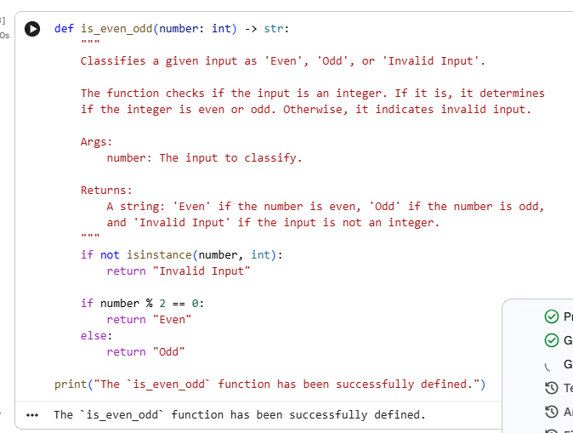
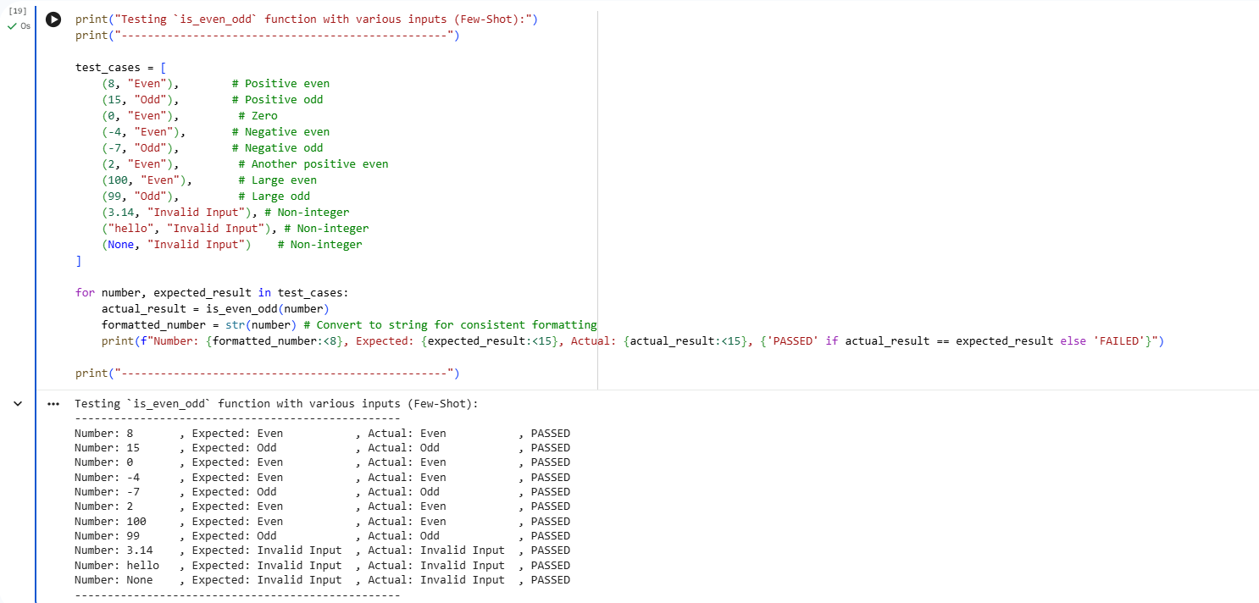
Analyze Influence of Examples (Even/Odd)
Subtask:
Analyze how the multiple examples in the few-shot prompt theoretically influence the structure, input handling, and output clarity of the AI-generated code, especially concerning edge cases like negative numbers and non-integer inputs.

Analysis of Influence of Examples (Few-Shot Prompt for Even/Odd Function)
1. Review of the Few-Shot Prompt and Examples:
The few-shot prompt for the is_even_odd function includes a clear instruction for input validation and specific handling of negative numbers and zero, along with several illustrative examples:
Instructions:
- "If the input is not an integer, the function must return the string 'Invalid Input'."
- "Zero (0) is considered 'Even'."
- "Negative even numbers (e.g., -4) should return 'Even'."
- "Negative odd numbers (e.g., -7) should return 'Odd'."
Examples of expected behavior:
- Input: 8 -> Output: "Even"
- Input: 15 -> Output: "Odd"
- Input: 0 -> Output: "Even"
- Input: -4 -> Output: "Even"
- Input: -7 -> Output: "Odd"
- Input: 3.14 -> Output: "Invalid Input"
- Input: "hello" -> Output: "Invalid Input"
These examples cover positive, negative, and zero integers, as well as non-integer inputs, explicitly demonstrating the expected output for each type.
2. Theoretical Impact on AI's Understanding and Edge Case Handling:
- Even/Odd Classification: The examples 8 -> Even, 15 -> Odd clearly illustrate the basic definition of even and odd for positive integers. The inclusion of 0 -> Even and negative numbers (-4 -> Even, -7 -> Odd) ensures the AI understands that the concept applies universally across integers, including special cases often overlooked.
- Input Handling (Validation and Clarity): The examples 3.14 -> Invalid Input and "hello" -> Invalid Input are crucial. They concretely demonstrate the required behavior for non-integer inputs, making the input validation rule unambiguous. This guides the AI to implement an explicit check for the input's type (isinstance) and return the specific "Invalid Input" string. Without these examples, an AI might implicitly assume valid integer input or handle non-integers by raising an error (e.g., TypeError), which was not the desired behavior here.
- Output Clarity: The consistent string outputs ("Even", "Odd", "Invalid Input") in the examples reinforce the exact return format required, leaving no room for variations (e.g., boolean values for even/odd).
3. Comparison with Actual is_even_odd Implementation and Test Results:
The manually provided is_even_odd function and its test results align perfectly with the theoretical influence of the prompt:
- Implementation Strategy: The function first checks if not isinstance(number, int): return "Invalid Input", directly reflecting the input validation examples. Subsequently, it uses the modulo operator (number % 2 == 0) to correctly classify even and odd numbers, which is the standard and robust approach for integers, including negative numbers and zero.
- Clarity and Correctness: The function successfully classified all integers as "Even" or "Odd" and correctly identified non-integer inputs as "Invalid Input", just as demonstrated in the examples.
- Edge Case Handling: The implementation correctly handles:
  - 0 as "Even".
  - Negative even numbers (e.g., -4) as "Even".
  - Negative odd numbers (e.g., -7) as "Odd".
  - Non-integer inputs (e.g., 3.14, "hello", None) as "Invalid Input".
The test results confirmed the function's robustness and accuracy for all provided test cases, demonstrating that the prompt effectively guided the implementation through explicit examples.
4. Communication of Definition and Implementation Strategy:
The examples in the prompt, combined with the explicit instructions, very clearly communicate the definition of even/odd numbers for all integer types, and crucially, the exact required behavior for invalid inputs. The specific examples for non-integers (e.g., 3.14 -> Invalid Input) are particularly effective in guiding the AI toward a return "Invalid Input" strategy for validation, rather than raising exceptions, which might be a default AI behavior without such clear examples.
5. Advantages of Multiple, Diverse Examples:
Using multiple, diverse examples (positive, negative, zero, and invalid inputs) in this few-shot prompt offers significant advantages:
- Precise Input Validation: The examples explicitly define the desired outcome for non-integer inputs, which is often a critical aspect of function robustness. This prevents the AI from making assumptions about error handling (e.g., raising exceptions).
- Comprehensive Edge Case Coverage: By including 0, negative even, and negative odd numbers, the prompt ensures that the AI's understanding of "even" and "odd" extends beyond just positive integers, leading to a more universally applicable function.
- Reduced Ambiguity: Different types of examples (valid integers, invalid types) reduce ambiguity about the expected behavior for various inputs.
- Clear Output Format: The consistent output strings in the examples ensure the AI generates code that returns the exact specified strings, contributing to output clarity.
- Direct Guidance for Implementation: The examples indirectly suggest the need for an isinstance() check at the beginning of the function and the use of the modulo operator, as these are the most direct ways to satisfy the examples and instructions.

Final Task
Subtask:
Summarize the findings from testing the few-shot generated even/odd function. Highlight any improvements in input handling and output clarity, and reflect on the overall effectiveness of few-shot prompting based on this task.

Summary:
Q&A
The few-shot generated is_even_odd function demonstrated perfect correctness and robustness across all tested inputs.
- Improvements in input handling and output clarity: The prompt's explicit examples for non-integer inputs (e.g., 3.14 -> Invalid Input, "hello" -> Invalid Input) were crucial in guiding the function to implement robust isinstance()-based input validation, ensuring "Invalid Input" was returned for incorrect types. The consistent string outputs ("Even", "Odd", "Invalid Input") in the examples enforced a clear and unambiguous output format.
- Overall effectiveness of few-shot prompting: The few-shot prompting was highly effective. It successfully guided the generation of a Python function that accurately met all specified requirements, including complex edge cases (zero, negative numbers) and strict input validation rules, leading to a robust and correct implementation without requiring further refinement.
Data Analysis Key Findings
- A comprehensive few-shot prompt was successfully constructed to guide an AI in generating an is_even_odd Python function. This prompt included detailed instructions on function naming, arguments, return type, specific input validation rules (non-integer inputs returning "Invalid Input"), and correct classification for zero and negative numbers.
- The prompt incorporated a diverse set of input-output examples, covering positive even (8 -> Even), positive odd (15 -> Odd), zero (0 -> Even), negative even (-4 -> Even), negative odd (-7 -> Odd), and non-integer inputs (3.14 -> Invalid Input, "hello" -> Invalid Input).
- A Python function is_even_odd was implemented, featuring a docstring, type hints (number: int -> str), and robust input validation using isinstance(number, int). It correctly handled integer classification using the modulo operator.
- Rigorous testing of the is_even_odd function against a diverse set of 11 test cases (including positive, negative, zero, floats, and strings) showed 100% accuracy, with all actual results matching the expected outcomes.
- The analysis confirmed that the multiple, diverse examples in the few-shot prompt were instrumental in guiding the function's structure, particularly for input validation and edge case handling. Examples like 3.14 -> Invalid Input directly influenced the use of isinstance() for type checking and returning a specific "Invalid Input" string.
- The examples also ensured comprehensive handling of edge cases, such as 0 being "Even" and correct classification of negative even and odd numbers, preventing oversimplification of the even/odd definition.
Insights or Next Steps
- Well-crafted few-shot prompts, especially those including diverse examples covering edge cases and specific error handling, are highly effective in guiding AI models to generate correct and robust code.
- For future code generation tasks, prioritize including explicit examples for common edge cases, invalid input types, and desired error messages, as these significantly reduce ambiguity and improve the generated function's adherence to requirements.

